

**16th Workshop on Spray Application and Precision Technology in Fruit Growing**

**Temporary program V3**

**Check Suprofruit website for updates !**

**https://suprofruit2023.colloque.inrae.fr**

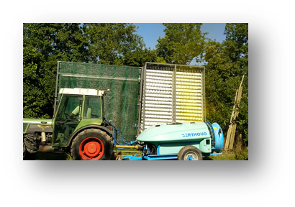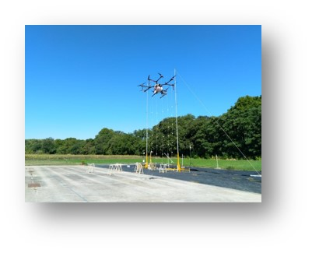

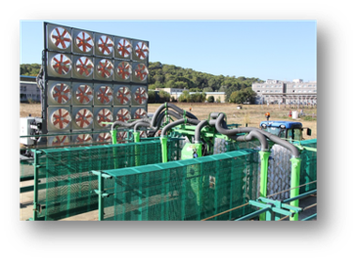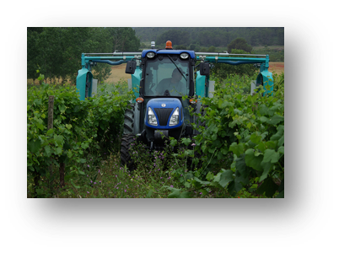

**Agropolis International**

**1000, Avenue Agropolis,**

**Montpellier, France**

**19 – 21 September 2023**

**Welcome to Suprofruit**

SuproFruit workshops have taken place biennially in Europe since 1991 with a primary focus on developments in spray application techniques in fruit and other three dimensional crops. The workshops offer a platform for scientists, researchers, technicians, advisors, manufacturers of spray equipment and industry from all over the world to present new ideas and developments, but also discussing various topics in a three-day workshop.

**Hot topics in fruit growing spray application – Workshop sessions**

|  |  |
| --- | --- |
|  | Session 1: Precision technologies and crop sensing in fruit growing |
|  | Session 2: Precision spray application to fruit crops |
|  | Session 3: Spray cover and deposition |
|  | Session 4: Pesticide dosing |
|  | Session 5: Spray atomization, air support, new technologies (incl. drones) for spray application |
|  | Session 6: Spray drift |
|  | Session 7: Knowledge exchange |
|  | Session 8: Environmental and operator safety related to fruit crop spraying |

**Tentative program (subjected to be modified)**

**Monday Sept 18th Welcome reception and registration**

Welcome of participants from 16h – 20h

INRAE

**Tuesday Sept 19th - Agropolis International**

Welcome of participants from 8h30

Welcome ceremony 9h00

Platform presentations 9h30 – 12h30

Lunch

Platform presentations 14h00 – 17h30

**Wednesday Sept. 20th – Field trip (provisory program)**

Visiting tour to the joint research team Ecotech (walking distance from Agropolis)

Transfer by bus to Mas de Jarasse (Listel® winery estate) visit of the domain & lunch

Transfer by bus to SudExpé (St Gilles)/CTIFL (Balandran) : Innovative techniques in fruit growing plant protection…

Transfer by bus to Domaine de Massillan (Le Crès) for the Gala dinner

Transfer by bus to Agropolis and downtown Montpellier

**Thursday Sept. 21st – Agropolis International**

Platform presentations 9h30 – 12h30

Lunch

Platform presentations 14h00 – 16h00

Closing remarks and good bye

**How to reach Montpellier and Agropolis International?**

By plane: Montpellier Airport (MPL) offers several daily connexions to Paris (either Paris Charles de Gaulle or Paris Orly Airports) and to several European places. Alternative airport is Marseille (MRS) with train connections to Montpellier.

By train: Be aware that **there are TWO railway stations in Montpellier!**

**Montpellier Saint Roch** is the original train station located downtown with connections to Paris, Marseille, Bordeaux

**Montpellier TGV Sud de France** is located 3km from downtown with fast train connections to Bruxelles, Barcelona, Lyon and Paris

By car: Montpellier is located in southeast France, connected by highways to Spain (Barcelona 300 km), Lyon (300 km), Paris (600 km), Marseille (250 km), Toulouse (250 km) from Paris. Montpellier and surrounding cities are progressively enforcing Low Emission Restrictions but exemption may apply. By July 1st 2023, cars with petrol engine older than 1997 and cars with diesel engine older than 2001 (Crit’Air 5) are no more allowed. Temporary derogations are possible. Check your situation here: <https://urbanaccessregulations.eu/countries-mainmenu-147/france/montpellier>

**How to reach Agropolis International**

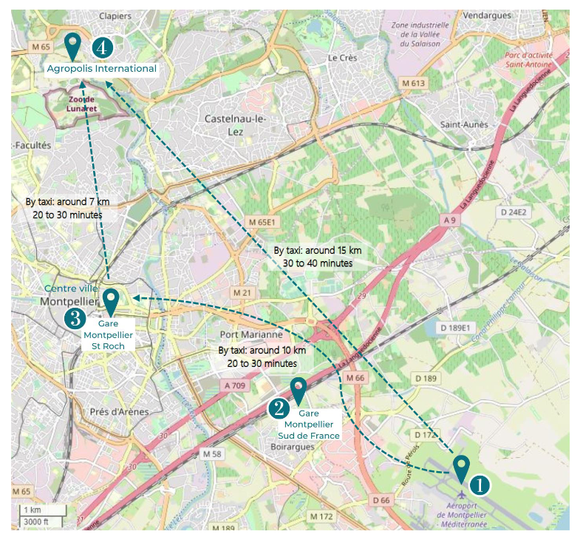

You may reach Agropolis International from many hotels downtown through Tram n°1 (Blue/Swallow) line direction “Mosson”. Follow instructions below as coming from the St Roch station.

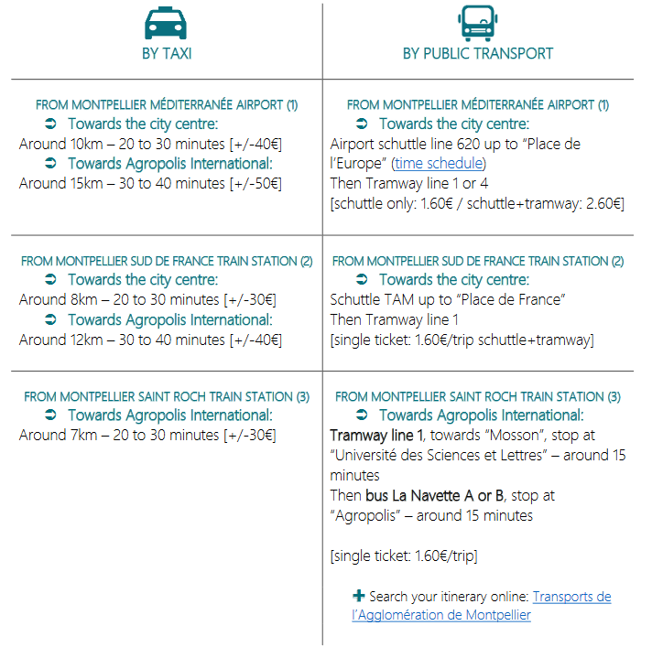

You can buy Tram/bus tickets at all Tram stations and inside buses (ask the driver). You may also download the app M’Ticket to buy e-tickets

<https://play.google.com/store/apps/details?id=com.tam_way.mobiletickets&hl=fr&gl=US>

**Find an accommodation in Montpellier?**

Montpellier is a touristic city with a wide range of accommodation types and prices. Website from the tourism office: <https://www.montpellier-france.com/>

There are many hotels located downtown close to the Railway Station Montpellier Saint Roch and Place de la Comédie. You may preferably select a hotel close to Tram line 1 for easier commuting. See above for Tram/bus connexions.

**The venue - https://www.agropolis.fr/**

Agropolis International is a non-profit association that brings together, within the Occitanie region in France, research and higher education organisations, local authorities, professional and civil society organisations, all of which develop activities in the fields of agriculture, food, biodiversity and the environment.

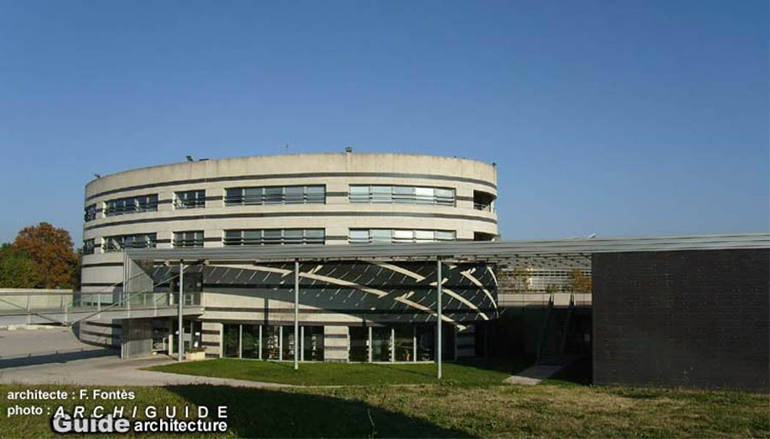

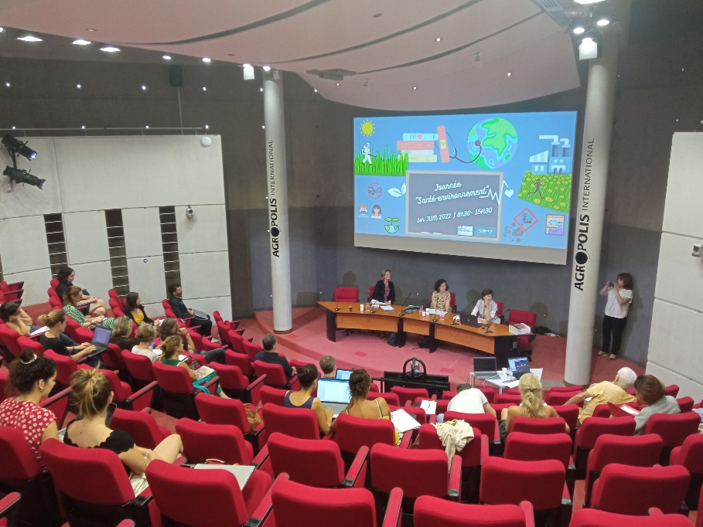

**Call for papers**

Abstracts are called to be sent for platform presentations (posters may also be presented during coffee breaks). Abstracts with max 300 words can be submitted on the Suprofruit 2023 Website <https://suprofruit2023.colloque.inrae.fr>

8 sessions were identified by Suprofruit scientific committee:

Session 1: Precision technologies and crop sensing in fruit growing

Session 2: Precision spray application to fruit crops

Session 3: Spray cover and deposition

Session 4: Pesticide dosing

Session 5: Spray atomization, air support, new technologies (incl drones) for spray applications

Session 6: Spray drift

Session 7: Knowledge exchange

Session 8: Environmental and Operator safety related to fruit crop spraying

**Proceedings:**

A Book of Proceedings will be edited and published by INRAE.

A template of abstracts is available from the Suprofruit web site : <https://suprofruit2023.colloque.inrae.fr>

**Deadlines**

15 April 2023 submission of abstracts

15 May decision SC

15 June submission of full abstracts

Reviews from the SC

Submission of final version

**Registration**

Follow Register Link on Suprofuit Website <https://suprofruit2023.colloque.inrae.fr>

**Workshop fees:**

The Workshop fee amounts are given in the table below:

|  |  |  |
| --- | --- | --- |
| Registration fees | Early bird March 1st -> July 31st 2023 | Late > August 1st 2023 |
| Full participant | 350 € incl. VAT | 400 € incl. VAT |
| Student (PhD, PostDoc) | 120 € incl. VAT | 150 € incl. VAT |
| Accompanying person (field visit day and gala) | 90 € incl. VAT | 120 € incl. VAT |
|  |  |  |

The fee includes costs of registration, proceedings, excursion, coffee, soft drinks, lunches, buffet dinner and workshop social dinner*. No refunds will be given after* 01/09/2023*.*

**Payment:**

Payment with a credit card is preferable. In case of a bank transfer, the effective registration will be considered when the transfer is operated. See on Suprofruit Webpage for details (link above).

Please remember to indicate on the heading/subject of the bank transfer: "Suprofuit23_Name of the attendant".

Registration will only be confirmed once payment has been checked.

**Organizing Committee:**

Jean-Paul DOUZALS, INRAE, [jean-paul.douzals@inrae.fr](mailto:jean-paul.douzals@inrae.fr)

Nesrine BOUCHEKOUM, INRAE, [nesrine.bpuchekoum@inrae.fr](mailto:nesrine.bpuchekoum@inrae.fr)

Sebastien CODIS, INRAE, [sebastien.codis@vignevin.com](mailto:sebastien.codis@vignevin.com)

Xavier CRETE, SudExpé, [xcrete@sudexpe.fr](mailto:xcrete@sudexpe.fr)

Elodie BROCHIER, INRAE, [elodie.brochier@inrae.fr](mailto:elodie.brochier@inrae.fr)

…

**Scientific Committee**

|  |  |  |
| --- | --- | --- |
| Résultat de recherche d'images pour "Marcel Wenneker" | Marcel WENNEKER | Suprofruit Convenor, Wageningen University Research (WUR), The Netherlands, [marcel.wenneker@wur.nl](mailto:marcel.wenneker@wur.nl) |
| **Macchine irroratrici, gli adempimenti relativi a controllo funzionale e  regolazione - Agrimeccanica - AgroNotizie** | Paolo BALSARI (Prof.) | University of Turin, Italy, [paolo.balsari@unit.it](mailto:paolo.balsari@unit.it) |
|  | Jean-Paul DOUZALS | INRAE, France,  [jean-paul.douzals@inrae.fr](mailto:jean-paul.douzals@inrae.fr) |
| **C:\Users\jean-paul.douzals\AppData\Local\Microsoft\Windows\INetCache\Content.MSO\7C3B95A.tmp** | Grzegorz DORUCHOWSKY | INHORT, Poland, [grzegorz.doruchowski@inhort.pl](mailto:grzegorz.doruchowski@inhort.pl) |
| **C:\Users\jean-paul.douzals\AppData\Local\Microsoft\Windows\INetCache\Content.MSO\660F1344.tmp** | Emilio GIL (Prof.) | University Polytechnic Catalonia (UPC), Spain, [emilio.gil@upc.es](mailto:emilio.gil@upc.es) |
|  | Kris RUYSEN | PC Fruit, Belgium, [kris.ruysen@pcfruit.be](mailto:kris.ruysen@pcfruit.be) |
| Climate Witness: Peter Triloff, Germany | WWF | Peter TRILOFF | Consultant, Germany, [peter.triloff@lindavino.de](mailto:peter.triloff@lindavino.de) |
| Résultat de recherche d'images pour "jan vande zande" | Jan Van de ZANDE | Wageningen University Research (WUR), The Netherlands, [jan.vandezande@wur.nl](mailto:jan.vandezande@wur.nl) |
| Dr Charles Whitfield | NIAB | Charles WHITFIELD | NIAB East Malling Research (NIAB EMR), United Kingdom, [charles.whitfield@niab.com](mailto:charles.whitfield@niab.com) |

,