Program

Monday Sept 18th Welcome reception and registration

Welcome of participants from **16h – 20h** - INRAE (walking distance from Agropolis building and bus stops). Address is 100 rue Jean-François Breton, 34000 Montpellier https://goo.gl/maps/QvPj3XJmwgvzADPU7

Agropolis

INRAE

Lavalette

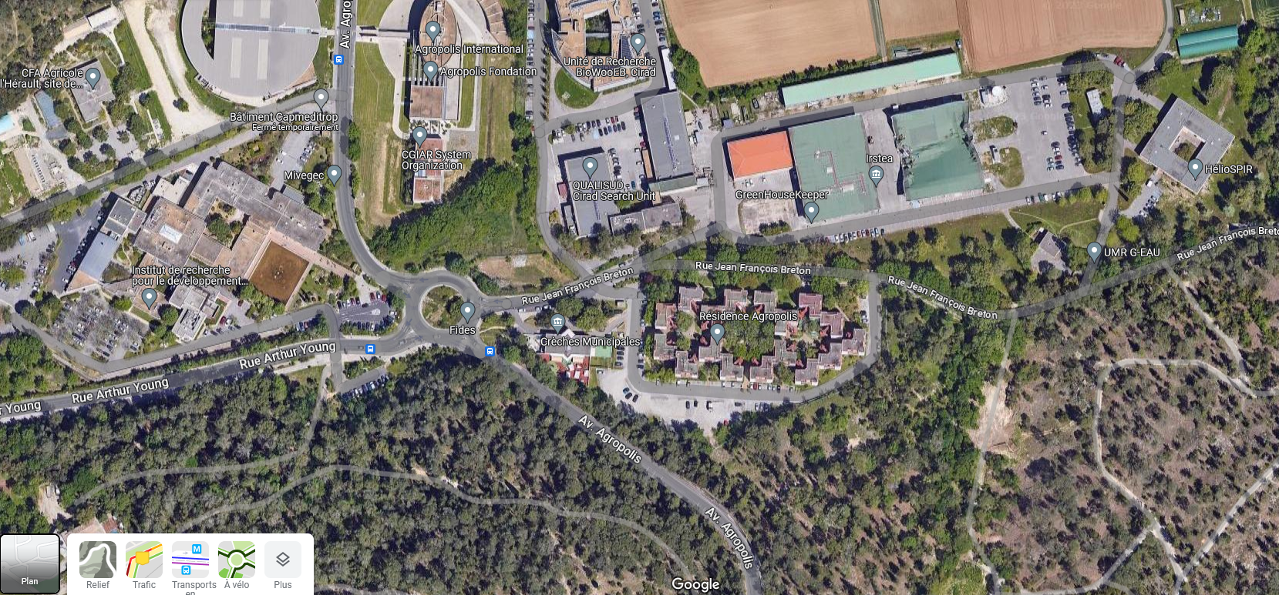

Welcome reception

Bus stop

Bus stop

Tuesday Sept 19th – Agropolis International

|  |  |  |  |
| --- | --- | --- | --- |
| Time |  | Name | Title |
| 8:30 |  | Agropolis International | Welcome coffee and registration |
| 9:00 |  | Welcome remarks | |
| 9:30 | Jan van de Zande | | Precision spray application in fruit growing: recent and future issues |
|  | Session 1 | **Session 1 - Chair : P. Balsari & P.H. Dubuis** | |
| 10:00 | Francisco Garcia-Ruiz | 1.1 Variable Rate Application in mountain viticulture based on canopy maps generated by satellite remote sensing |
| 10:20 | Lars Berger | 1.2 3D Computer Vision for Real Time Sprayer Adjustments |
| 10:40 | Erdal Ozkan | 1.3 Current Status of Real-time Target-oriented Spray Application Research in Ohio |
| 11:00 |  | Coffee Break |  |
|  | Session 2 | **Session 2 - Chair : P. Triloff & F. Verpont** | |
| 11:20 | Sebastien Codis | 2.1 PERFORMANCE PULVÉ®: a labelling system for vineyard sprayers based on their performance in terms of spray quality and potential for PPP dose reduction. Review after two years of implementation |
| 11:40 | J Gideon Van Zyl | 2.2 Evaluating the influence of drape netting on spray deposition and disease control in apple orchards using apple scab as a model pathogen |
| 12:00 | Vincent Philion | 2.3 Row by row exclusion netting in apple orchards negatively impact spray deposition but don’t prevent spray efficacy. |
| 12:20 |  | Lunch at Agropolis | |
|  | Session 3 | **Session 3 - Chair : G. Doruchowski & P. Chueca** | |
| 13:40 | Marco Grella | 3.1 Effect of UASS spray application rates on vines canopy deposit |
| 14:00 | Daniel Bondesan | 3.2 Hydraulic-based fixed spray delivery system: preliminary result of apple scab management in Italy |
| 14:20 | Pierre-Henri Dubuis | 3.3 Determination of drift and exposure of bystanders and residents during treatment with a UASS in an apple orchard |
| 14:40 | Pengchao Chen | 3.4 Spray quality assessment of unmanned aerial spraying system in tropical fruit trees in southern China |
| 15:00 | Jean-Paul Douzals | 3.5 Return on Experience on the use of UASS for plant protection application on crops grown on steep slopes in France. |
| 15:20 | Santiago Planas de Marti | 3.6 Assessment of Unmanned Aerial Sprayer Systems (UASS) for drift and spray quality. |
| 15:40 |  | Coffee break |  |
|  | Session 4 | **Session 4 - Chair : P. Marucco & C. Garcera** | |
| 16:00 | Jan van de Zande | 4.1 Airborne spray drift and ground deposition spraying an orchard with standard and drift reducing techniques |
| 16:20 | Adrien Verges | 4.2 Spray drift measurements in 3D crops using several collection methods. Evaluation of different scenarios in the French context. |
| 16:40 | Katrin Ahrens | 4.3 Drift 3D, exposure of residents and bystanders during the application of plant protection products in orchards |
| 17:00 | Kris Ruysen | 4.4 Drift reducing effects on wind break screens |
|  | Session 5 | **Session 5 - Chair : K. Ruysen & S. Grimbuhler** | |
| 17:20 | Roberto Beltrán-Martí | 5.1 Do hydraulic pumps of sprayers influence the performance of Beauveria bassiana (Balsamo) Vullemin as biocontrol agent? |
| 17:40 | Nesrine Bouchekoum | 5.2 Main defaults of vine and orchard sprayers observed during sprayer inspection |
| 18:00 |  | End of the day |  |

Wednesday Sept. 20th – Field trip

|  |  |
| --- | --- |
| time | 20/06/2023 |
| 8:30  9:00 | Meeting at Agropolis and short walk to INRAE  Field demos on spray deposition, spray drift – INRAE  <https://goo.gl/maps/XhEaJZu9fHDGeMRH9> |
| 11:30 | Transfer by bus Lunch and visit at Domaine royal de Jaras (wine estate) Le Grau du Roi  <https://goo.gl/maps/zaTV6GsgYh6FJWEf7> |
|
|
|
| 15:00 | visit of CTIFL Balandran field demos Bellegarde  <https://goo.gl/maps/KRXvAPsG3JPc3ujS8> |
| 18:30    22:00 | Gala diner at Domaine de Massillan  Le Crès  <https://goo.gl/maps/CrNLmm48pVBajQxJA>  Transfer by bus to Montpellier |
|
|

Thursday Sept. 21st – Agropolis International

|  |  |  |  |
| --- | --- | --- | --- |
| Time |  | Name | Title |
| 8:10 |  | Anne Alix | Introduction to the European Precision Application Task Force (EUPAF): remit and ongoing activities |
|  | Session 1 | **Session 1 – Chairs: E Gil & E Ozkan** | |
| 8:40 | Patricia Chueca | 1.4 Spray technologies in 3D crops grown in Southern Europe: a state-of-the-art survey |
| 9:00 | Zbigniew Czaczyk | 1.5 Do the different field scenarios require properly optimized droplet characteristics? |
| 9:20 | Charles Whitfield | 1.6 Blackberry Fruit Ripeness Analysis – Working Towards Application of Augmented Reality on Farms |
| 9:40 | Anice Cheraiet | 1.7 LIDAR based Porosity and LAI measurement: Can we use LIDAR scanning on one side only? |
| 10:00 |  | Coffee Break |  |
|  | Session 3 | **Session 3 – Chairs: C Whitfield & A. Landers** | |
| 10:20 | Eric Mozzanini | 3.7 Cleaning performance of a pneumatic-based SSCDS designed for crop protection in modern orchard systems |
| 10:40 | Tobias Hüni | 3.8 Thanks to air support: Spray effectively and efficiently from 0.5 up to 13m and saving up to 40% liquid |
| 11:00 | Peter Triloff | 3.9 Target Adapted Dosing and Spray Application in 3D Crops |
| 11:20 | Gaétan Fleury | 3.10 The aeroconfined© BLISS-ecospray concept, a new type of sprayer to eliminate sprayer losses at their source |  | Coffee Break |
|  | Session 2 | **Session 2 – Chairs: J.P. Douzals & K. Ahrens** | |
| 11:40 | Yoan Hudebine | 2.4 PerformancePulvé Arbo: comparative assessment of orchard sprayer efficiency under standardized indoor conditions |
| 12:00 | Tanja Pelzer | 2.5 OptiSpray: Sprayer classification for pesticide savings based on deposition and efficacy trials in orchards and vineyards |
| 12:20 | Justine Garnodier | 2.6 Influence of application material on spray deposition on strawberry in tabletop growing system |
| 12:40 | Jean-Marie Michielsen | 2.7 Deposition of coarse droplets in dormant apple trees |
| 12:45 | Adel Bakache | 2.8 A new tool and a rapid methodology to assess the spray application quality in vineyards and orchards |
| 12:50 | Lunch and Posters | |
| 14:00 | Grzegorz Doruchowski | 2.9 Spray deposition and loss during different application scenarios performed by orchard sprayer with individually adjusted air-jets |
|  | Session 4 | **Session 4 – Chairs : J. vande Zande & S. Planas** | |
| 14:20 | Nils Bjugstad | 4.5 A novel and simple method for potential spray drift measurements in orchards |
| 14:40 | Cruz Garcera | 4.6 Reduction of pesticides in the environment by the use of CitrusVol tool and spray drift reduction techniques during applications in citrus |
| 15:00 | Jean-Paul Douzals | 4.7 ADDI Spray Drift: A spray drift model for vine sprayers |
| 15:20 | Dirk de Hoog | 4.8 A novel method for drift calculations in orchards |
|  | Session 5 | **Session 5 – Chairs : M Wenneker &** **T. Pelzer** | |
| 15:40 | Sonia Grimbuhler | 5.3 NewPom Project: Worker exposure to pesticides in apple orchards |
| 16:00 | Paolo Marucco | 5.4 Indoor measurements to develop a methodology for spray mass balance assessment from air-assisted sprayers |
| 16:20 |  | Closing remarks and Farewell | |